**Diverse collection of wild *Drosophila melanogaster* reveals the evolutionary history of a persistent viral infection**

**Alexandra H. Keene-Snickers1,2, Ali L. Brehm1, Taylor Gelpi and Mark D. Stenglein1\***

1. Center for Vector-Borne and Infectious Diseases, Department of Microbiology, Immunology, and Pathology, College of Veterinary Medicine and Biomedical Sciences, Colorado State University, Fort Collins, CO, USA
2. Quantitative Cell and Molecular Biology Graduate Program

\* Correspondence to: [Mark.Stenglein@colostate.edu](mailto:Mark.Stenglein@colostate.edu)

**ABSTRACT**

It is commonly understood that viruses, particularly RNA viruses, evolve at high rates. However, as more viruses are discovered it is evident that the study of viruses have been biased towards those of human, animal or plant health importance. Viral infections that can infect their host without appearing to cause any disease are being discovered. Yet, little is known about the biological and evolutionary roles these viruses play within their host and other microbiota. Evidence suggests that some of these viruses evolve at slower rates than other viruses, but their evolutionary patterns are not well known. Galbut virus, a ubiquitous, vertically transmitted and persistent viral infection of *Drosophila melanogaster* is an ideal model to study persistent virus evolution. Sequences were recovered from wild *D. melanogaster* collected from locations across the United States. These sequences were used to make phylogenetic trees to investigate the evolutionary patterns of a galbut virus infection. The trees revealed that galbut virus diversity is surprisingly low, even in populations that were intensely surveyed. Coinfection patterns showed that coinfection occurred in a segment independent manner and that the presence of infections from different genotypes was rare. There was evidence of reassortment between potentially extinct or incredibly rare galbut virus clades. The data collected here support that there are differences in viral evolution caused by the relationship the virus has with its host. This data suggests that some persistent viral infections are under less selective pressure than would be normally calculated providing evidence for a tight host-virus interface.

**INTRODUCTION**[NO\_PRINTED\_FORM]

Galbut virus is a tri-segmented double-stranded (ds) RNA virus from the partitivirus family that infects *Drosophila melanogaster* and *Drosophila simulans*1,2. “Chaq virus” is either an optional fourth galbut virus segment or satellite virus1,3. Galbut virus appears to have limited impact on its hosts health. One study found that infection resulted in reduced offspring numbers4. Another found that it did not reduce offspring numbers but that it decreased the infected fly’s ability to fight fungal infections5. Galbut virus is globally distributed; every wild population examined thus far has some infected flies. This is likely due to the ubiquitous nature of *D. melanogaster* in human environments6 and the mode of transmission from parent to offspring at near 100% efficiency1.

A number of questions about galbut virus evolution and its impact on host biology remain unanswered. Three clades of galbut virus have been identified, two that infect *D. melanogaster* and one that infects *D. simulans*. The characteristics of these clades such as their abundance, whether they cocirculate and if there are different infection kinetics is not well understood.

The recent sequencing of *D. melanogaster* from museum collections suggests that galbut virus evolves slower than expected, a phenomenon seen in other partitiviruses. What drives this low substitution rate and what it means for virus-host interactions is unclear.

It has been estimated that galbut virus has been infecting flies for at least 200 years3. The presence of a near complete integrated copy of galbut virus segment 1 and that it infects multiple hosts suggests that it has been infecting flies for much longer. Therefore, more sequencing data is necessary to calculate an accurate time to most recent common ancestor2,7.

To study galbut virus diversity and evolution, we collected *D. melanogaster* from Colorado, Maine, Pennsylvania and Ohio over the summer of 2023. Nearly 1,000 flies were collected and 155 of them were sequenced. This resulted in the recovery of 374 galbut virus and chaq virus sequences. We found that overall galbut virus diversity within genotype was low but there was more diversity across genotypes. We also found evidence of either rare or extinct lineages. We primarily investigated the differences between genotypes. We found that the presence of chaq virus is incredibly rare in genotype B infections and that infections can result in high or low infection levels in genotype A but not B. Our investigation of reassortment patterns showed that reassortment between genotypes is possible but uncommon. Finally, we found that coinfection of galbut virus occurs often and does not require all segments. Collectively, these data suggest that galbut virus

**RESULTS**

**Galbut virus prevalence does not vary by location but can vary over time**

To better understand galbut virus prevalence and diversity, we collected flies from four states in the United States. We collected flies from nine locations in Larimer County, Colorado, and from one location in Maine, Pennsylvania, and Ohio (**Fig. 1A & 1B**). Flies we collected from JFK Parkway were isolated from peaches obtained from a Colorado grocery store, which may have originated elsewhere. For the purposes of this manuscript, they have been considered as a Colorado location. We used buckets baited with banana and yeast to collect flies from Colorado. Volunteers used previously designed 3D printed fly traps to collect flies from Maine, Ohio and Pennsylvania8. We instructed the volunteers to collect from these traps for as long as possible before sending the flies to our lab. We collected and tested ~1000 individual flies from all locations.

RNA from individual flies was screened for galbut virus via RT-qPCR (**Fig. 1C**). Ribosomal protein L32 mRNA levels were used to normalize galbut virus levels. Of the ~1000 flies captured, 952 were positive for RpL32 mRNA, indicating successful RNA extraction and 641 were positive for galbut virus. In the Colorado locations galbut virus prevalence varied from 53% to 100% (Adobe-100%, Briarwood- 40%, Elm- 69%, JFK Parkway- 97%, James- 86%, Linden- 88%, Myrtle- 65%, Rampart- 53% and Wabash- 77%). In Maine, Ohio and Pennsylvania prevalence was 77%, 33% and 97%, respectively. It is important to note that some locations are underrepresented while others are overrepresented. When we performed a logistical linear regression to determine if location was a factor in galbut virus prevalence we found that there was no impact on galbut virus prevalence by location (p > 0.9).

Rampart and Wabash were sampled over three months. When we stratified by time and performed a logistical linear regression, we found a statistically significant difference in galbut virus prevalence between all sampling events in the Rampart samples. When we did the same for Wabash, we found that there was a statistically significant difference in prevalence between July and August (p < 0.005) but not between August and September (p = 0.414) (**Fig. 1D**).

Overall, galbut virus was highly abundant in all populations tested except the Ohio samples. The decrease of abundance in the Ohio samples is likely due to these samples not being D. melanogaster. Of the 17 samples obtained from Ohio only three were positive for RpL32 mRNA and two of those samples had ct values higher than 20 (RpL32 mRNA is expected to be abundant in the fly and should therefore have ct values below 20) suggesting that these were closely related to *D. melanogaster* but ultimately a different species.

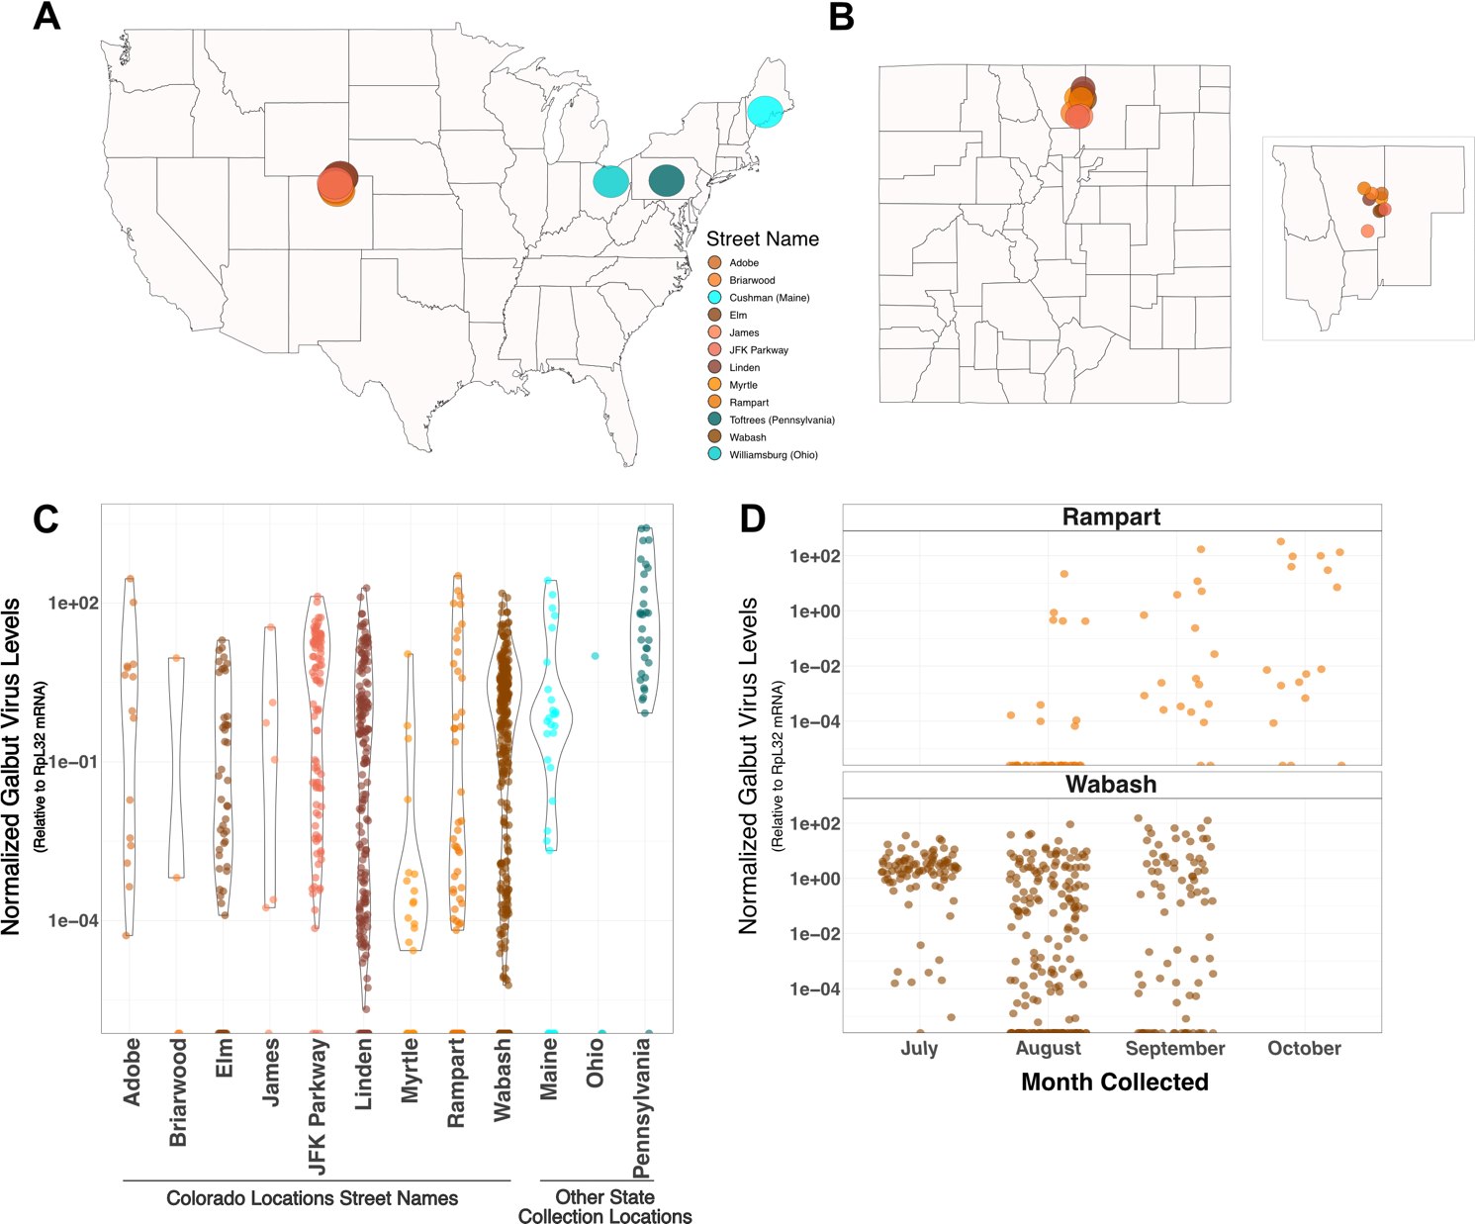

**Figure 1: Galbut virus infection is widespread in populations studied in Colorado, Maine, Ohio and Pennsylvania**. (A) Locations in the United States that wild *Drosophila* were collected in 2023. (B) Locations in Larimer county Colorado wild Drosophila were collected in 2023. Inset shows Larimer county with Weld, Boulder, Jackson and Grand counties as references. (C) Relative levels of galbut virus RNA 1 to RpL32 mRNA detected in flies captured in 2023. Figure is sorted by alphabetically by locations in Colorado (orange/brown colors) and other states (blue colors). Negative samples were set to zero. (D) Galbut virus infection over time in two locations of Larimer County, CO (Wabash and Rampart). RT-qPCR data is normalized to levels of RpL32 mRNA. Colorado locations are denoted by street names of the collection location.

**Galbut virus abundance is correlated between RT-qPCR levels and sequencing reads**

Of the ~1,000 samples collected, we selected 155 from which to recover galbut virus sequences using total RNA sequencing. Samples were selected to provide broad representation of geography, infection level, and galbut virus genotype (**Table 1**). Thirty-two of the sequenced samples did not contain enough galbut virus-mapping reads to generate coding complete sequences. From the 123 samples with sufficient galbut virus-mapping reads, we recovered 374 coding complete or near complete galbut virus segment sequences. Of the samples that yielded no coding-complete galbut virus sequences, six were from Ohio and had been sequenced because they were not *D. melanogaster* but could have been infected by a virus similar to galbut virus, 22 were low positives, four were detected by only one set of our galbut virus RT-qPCR primers.

We wanted to first look at whether galbut virus levels in RT-qPCR were correlated to the number of reads in our sequencing data. In a linear model, there was an strong correlation between relative galbut virus RNA and reads per million (p < 0.001).

**Table 1: Sequenced wild *D. melanogaster* metadata.**

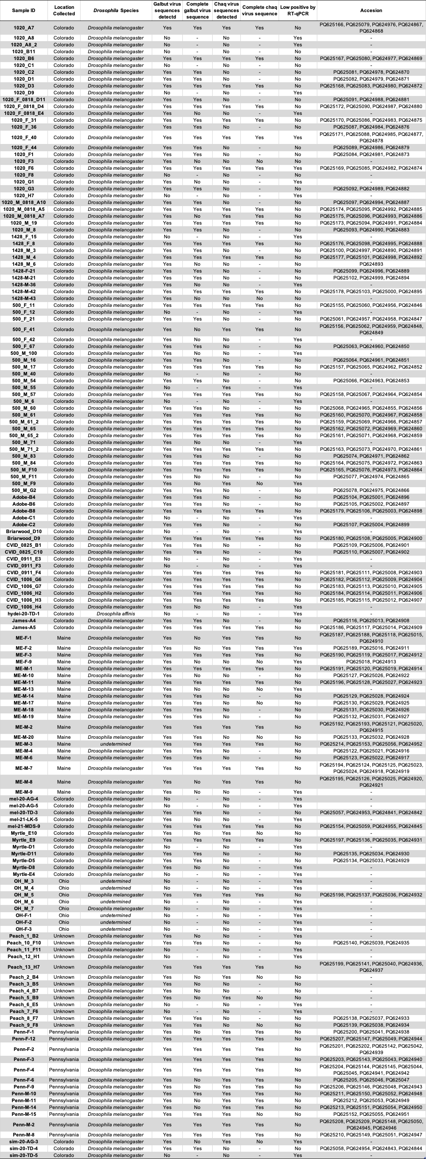



**Figure 2: Galbut virus RT-qPCR infection level and number of reads obtained are correlated.** X-axis denotes the log10 of galbut virus RNA 1 in reads per million. Y-axis denotes the log 10 of relative galbut virus levels normalized to RpL32 mRNA. Regression line denotes correlation between reads and levels identified via RT-qPCR.

**Galbut virus coinfection does not require all three segments**

We next wanted to understand the coinfection patterns of galbut virus and chaq virus. We found that 41 samples (33%) exhibited evidence of coinfection. Three of these samples corresponded to simple co-infections, with two sets of three galbut virus segments (**Fig. 3**). Interestingly, these were the only samples with multiple RNA1 segments. RNA 1 was the most common coding incomplete sequence. Sequencing depth was too low to recover RNA 1 sequences from 28 samples (**Fig. 3**).The other co-infections contained variable numbers of genotypes of the different segments. For instance, sample 1020-A7 contained 1 genotype for RNA1, RNA2, and chaq, but 2 distinct RNA3 genotypes that only shared 98.8% pairwise nucleotide identity. Sample ME-F-1 had one RNA 1, two RNA 2s, two chaq viruses and three RNA 3 segments. This was the only sample to show evidence of more than two sequences for any segment (**Fig. 3**). Additionally, no sample from Colorado had evidence of chaq virus coinfection (**Fig. 3**). This type of partial co-infection has been observed for other segmented RNA viruses9–11. For a heatmap containing sequence counts that were submitted to GenBank, please see **Supplemental Figure 1**.

****

**Figure 3: Coinfection of galbut virus does not require all three segments.** Heatmaps depicting the number of sequences recovered for each segment for samples with at least one coinfection (A) or with no evidence coinfection (B). Samples are sorted by location.

**Supplemental Figure 1: Heatmap of coding-complete and partial sequences submitted to GenBank under accessions PQ624841 - PQ625194 and PQ625196 - PQ625214**. Data as in Figure 3 except only samples with sequences submitted to GenBank are shown.

**Within genotype galbut virus diversity is low but high between genotypes**

We next wanted to investigate the similarity of galbut virus sequences across populations. We generated maximum likelihood phylogenetic trees using the galbut virus sequences generated here and those available through GenBank. To be included in the alignment, existing sequences had to derive from a single fly (not a pool of flies), and have a known collection year and location. We also generated galbut virus RNA 2 and 3 sequences from Sequence Read Archive (SRA) datasets for which galbut virus RNA 1 and Chaq virus sequences were available2.

For all galbut virus segments and chaq virus overall diversity within and between populations was low (**Fig. 4, 5, 6 & 7**). Following previous data, galbut virus segments one and two indicate that there are three genotypes (**Fig. 4 & 5**)12. However, the addition of more galbut RNA 3 sequences revealed that there are two distinct subclades of clade A, we have termed these galbut virus clade A.1 and A.2 (**Fig. 6**). Chaq virus also clustered into three clades (**Fig. 7**). Interestingly, galbut virus segments two and three showed that the *D. simulans* clade was related to galbut virus clade A while the *D. simulans* clade in segment one was related to clade B (**Fig. 4, 5, & 6**). However, this could be an artifact of midpoint rooting on tree topology. The *D. simulans* clade of chaq virus was separate from all the *D. melanogaster* sequences (**Fig. 7**).

Even with the goal of enriching for clade B sequences based off our RT-qPCR data, we recovered more clade A sequences. Of the 123 samples sequenced with galbut virus reads recovered, --- sequences fell into clade A and --- fell into clade B.

Geography partially explained phylogenetic clustering. For example, all the Pennsylvania samples clustered together (**Fig. 4, 5 & 6**). Similarly, the Australia samples clustered together except for a reassortant sample in RNA 1 (**Fig. 4, 5 & 6**). The Maine samples however were more diverse and were spread throughout the trees (**Fig. 4, 5 & 6**). It is important to note that all other sequences fell within the diversity of the Colorado sequences whether they were clade A or B.

Does sampling *date* explain phylogenetic clustering? Add a paragraph or include in preceeding one.

We next evaluated evidence for diversifying or purifying selection in galbut virus. Botella et al reported purifying selection in the RNA 1 and RNA 2 segments of a fungus-infecting partitivirus13. We employed the Fixed Effects Likelihood model described by Kosakovsky-Pond and Frost to quantify evidence of selection in each galbut virus segment and chaq virus14. There was little evidence of diversifying selection in galbut virus RNA 1, RNA 2 and chaq virus with two, two and four sites identified, respectively in each segment (**Table 2**). However, galbut virus RNA 3 showed more evidence of diversifying selection, with 20 sites identified (**Table 2**). For all segments there was more evidence of purifying selection, with 135, 58, 51, and 21 sites identified in galbut virus segments RNA 1, 2, 3 and chaq virus respectively (**Supplemental Table 1**).

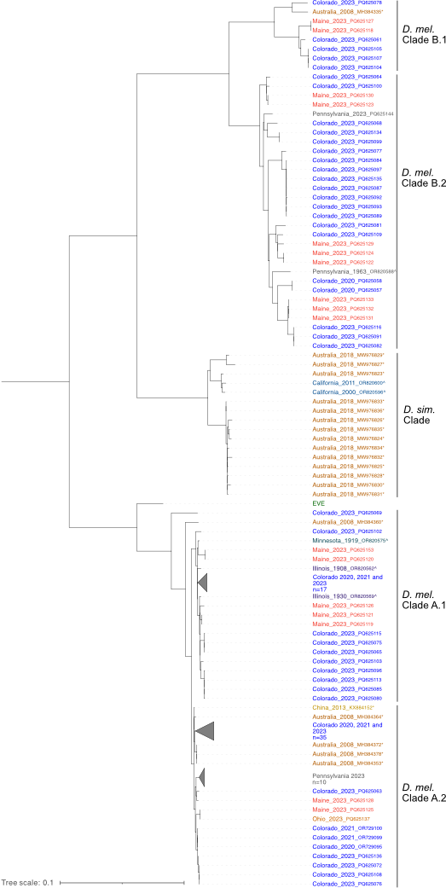

**Figure 4: Midpoint rooted maximum likelihood phylogenetic tree of galbut virus RNA1 nucleotide sequences.** Sample names are colored by location. Sequences generated by other investigators are indicated with an (\*).Sequences from museum specimens are indicated by a (+)12. Support values are shown for select nodes. Accession numbers are noted except where groups of closely related sequences were collapsed.

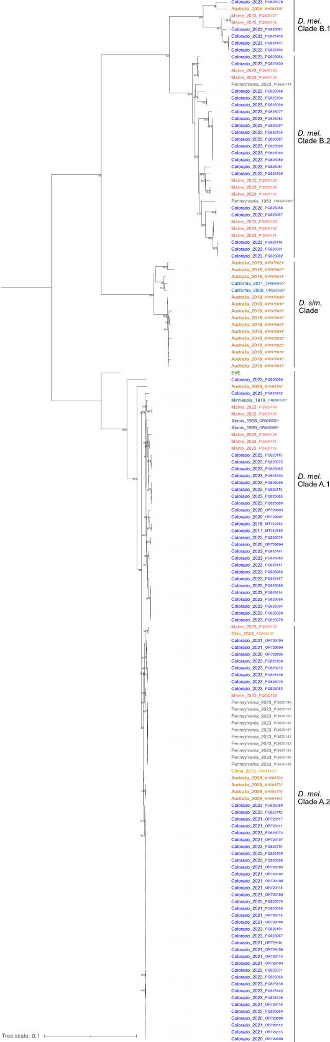

**Supplemental Figure 2: Midpoint rooted maximum likelihood tree of galbut virus RNA 1 nucleotide sequences extended data.** Data as shown in Figure 4 but with no clades collapsed.

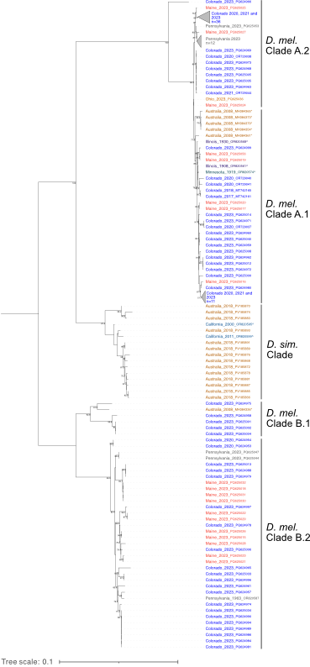

**Figure 5: Midpoint rooted maximum likelihood phylogenetic tree of galbut virus RNA2 nucleotide sequences.** Sample names are colored by location. Sequences generated by other investigators are indicated with an (\*).Sequences from museum specimens are indicated by a (+)12. Support values are shown for select nodes. Accession numbers are noted except where groups of closely related sequences were collapsed.

**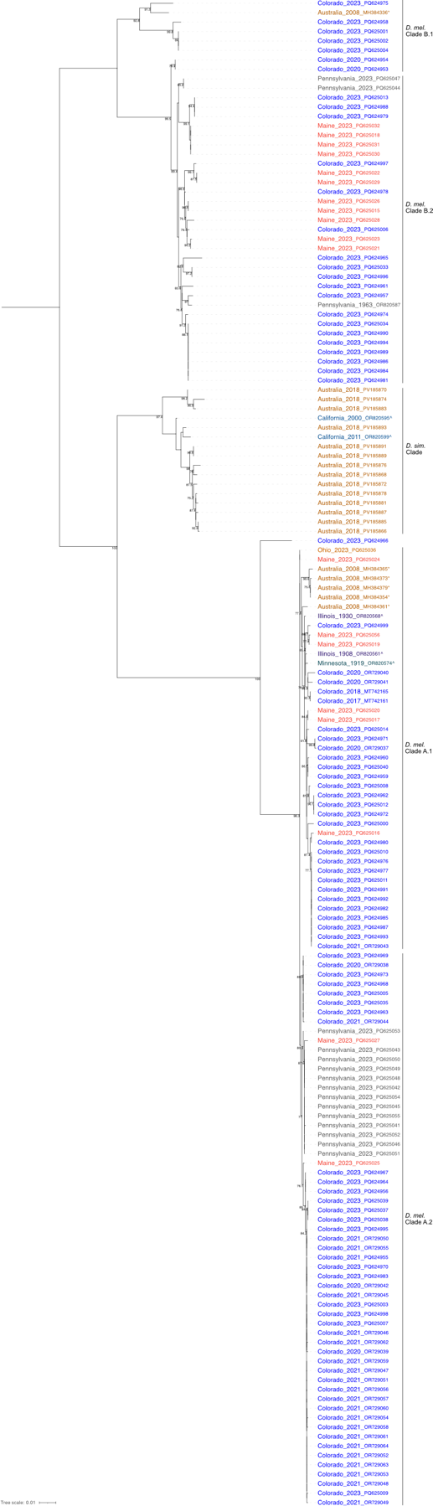**

**Supplemental Figure 3:** **Midpoint rooted maximum likelihood tree of galbut virus RNA 2 nucleotide sequences extended data.** Data as shown in Figure 5 but with no clades collapsed.

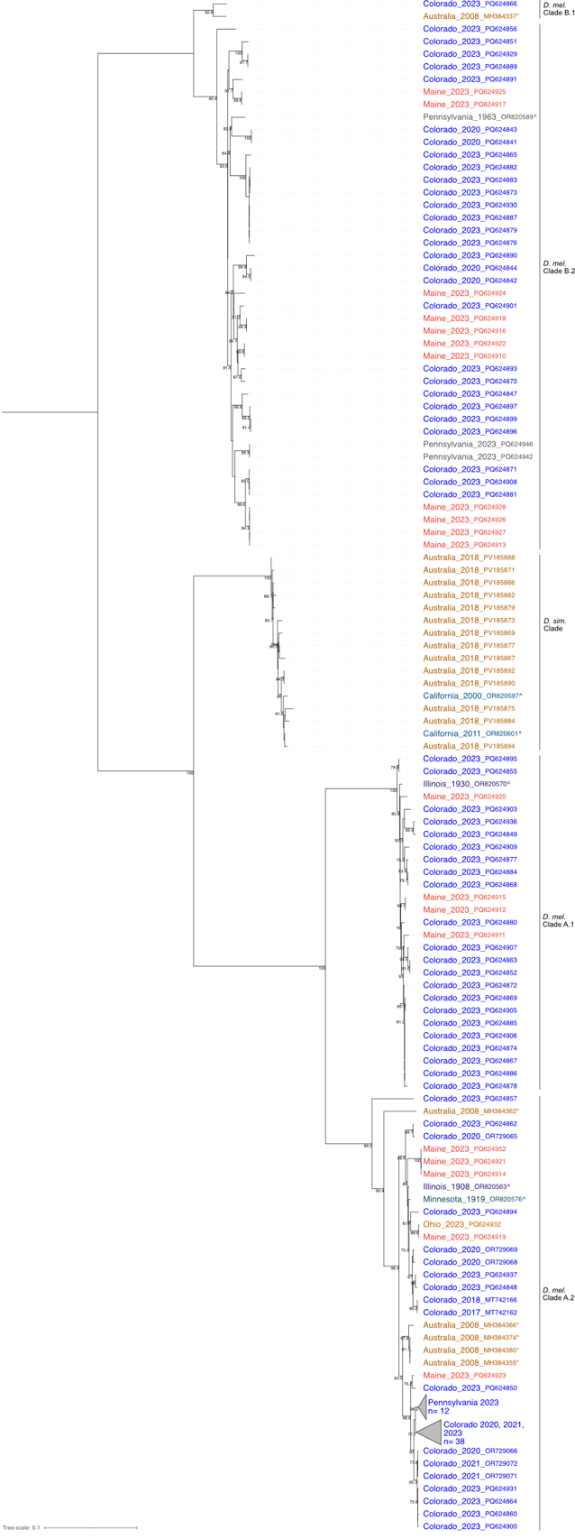

**Figure 6: Midpoint rooted maximum likelihood phylogenetic tree of galbut virus RNA3 nucleotide sequences.** Sample names are colored by location. Sequences generated by other investigators are indicated with an (\*).Sequences from museum specimens are indicated by a (+)12. Support values are shown for select nodes. Accession numbers are noted except where groups of closely related sequences were collapsed.

**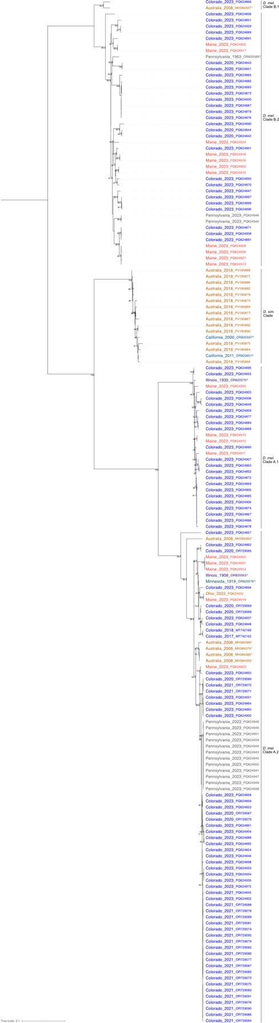**

**Supplemental Figure 4:** **Midpoint rooted maximum likelihood tree of galbut virus RNA 3 nucleotide sequences extended data.** Data as shown in Figure 5 but with no clades collapsed.

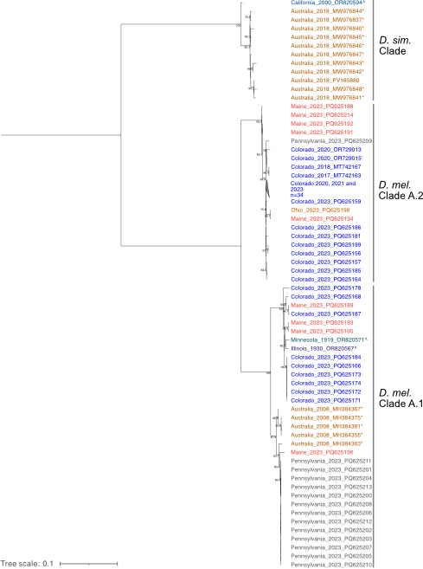

**Figure 7: Midpoint rooted maximum likelihood phylogenetic tree of chaq virus.** Sample names are colored by location. Sequences generated by other investigators are indicated with an (\*).Sequences from museum specimens are indicated by a (+)12. Support values are shown for select nodes. Accession numbers are noted except where groups of closely related sequences were collapsed.

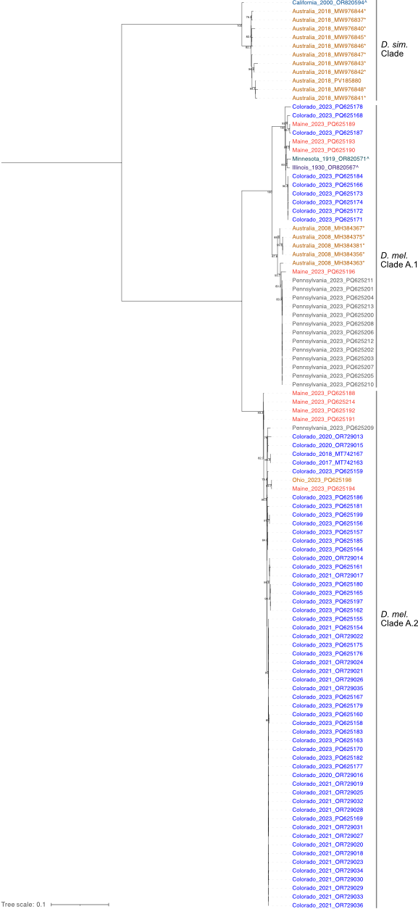

**Supplemental Figure 5:** **Midpoint rooted maximum likelihood tree of chaq virus nucleotide sequences extended data.** Data as shown in Figure 5 but with no clades collapsed.

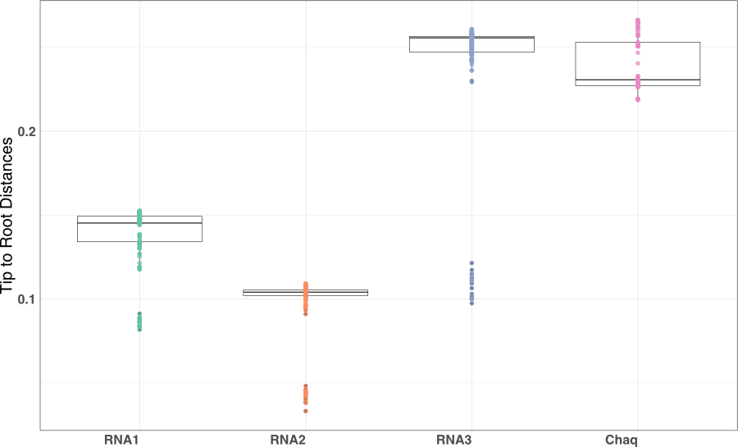

**Figure 8: Galbut virus RNA 3 and Chaq virus sequences are more divergent than galbut virus RNA 1 and 2.**

**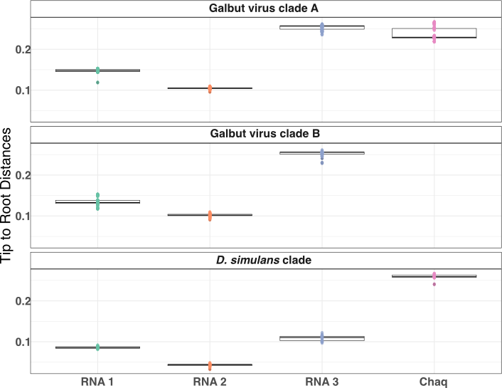**

**Supplemental Figure 6: Galbut virus and chaq virus sequence diversity between genotype is similar.**

**Table 2: Sites experiencing diversifying selection.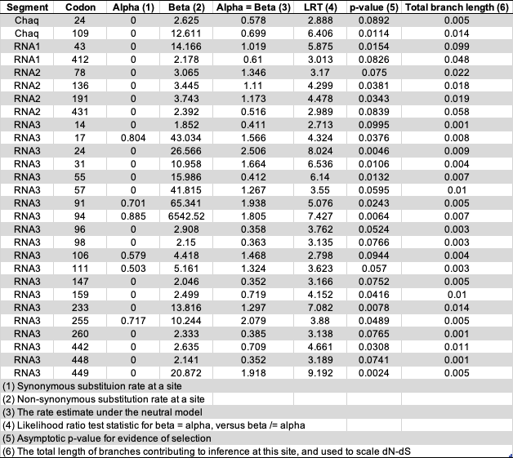**

**Supplemental Table 1: Sites experiencing purifying selection.**

**Galbut virus low and high infection level is associated with genotype A but not B**

We next asked whether different galbut virus genotypes were associated with different phenotypes. were next curious whether there was a distribution in the number of reads mapping to galbut virus and chaq virus based on low or high infection status and the presence of chaq virus. In agreement with our RT-qPCR data (**Fig. 1B & 1C**), the number of reads per million (RPM) mapping to galbut virus showed that there were low and high levels of infection (**Fig. 8**). However, the number of reads mapping was not necessarily similar for each galbut virus segment in a sample. There are fewer chaq virus sequences associated with the low infection samples however, the distribution of high and low infection status was present in chaq virus genotype A (**Fig 8**).

In contrast to our RT-qPCR data, there was limited evidence of low and high infections in the genotype B samples. Overall, there were the fewest reads mapping to RNA 1 and the most mapping to RNA 3 (**Fig. 8**). Since chaq virus is rarely associated with genotype B we are unable to say whether the presence of chaq virus influenced the levels of galbut virus however, the one genotype B sample with chaq virus was one of the samples with more RPM (**Fig. 8**).

**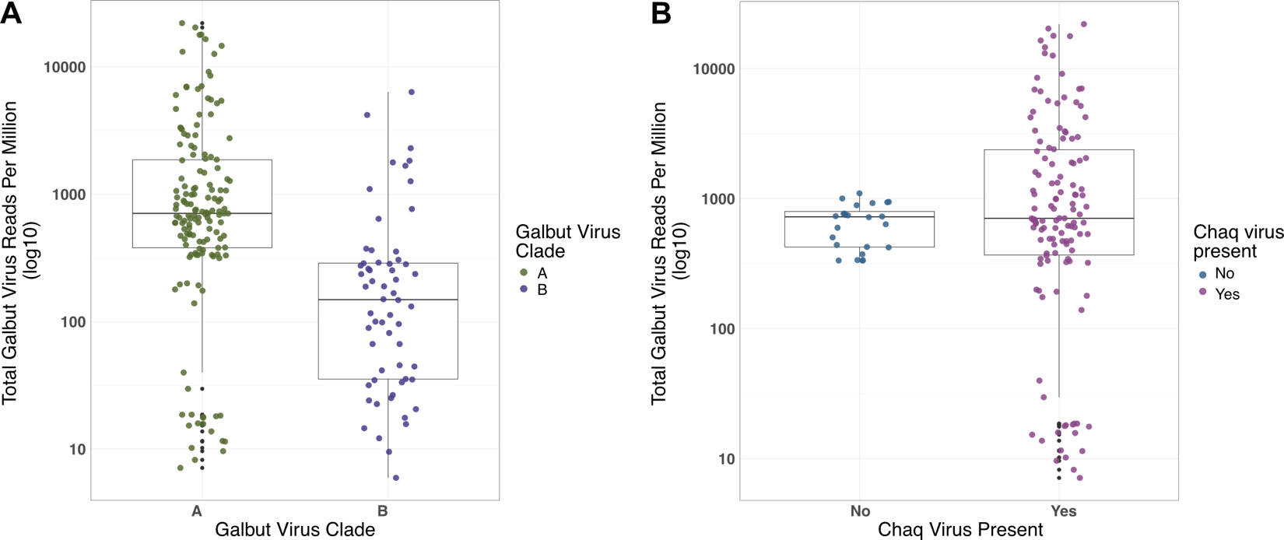**

**Figure 9: Galbut virus genotype A is characterized by two distinct infection levels.** Reads per million total reads per sample are shown for chaq virus and each galbut virus segment. The y-axis is scaled by log10 and the plot is split into samples identified as genotype A or B. Points are colored and shaped by the presence of chaq virus.

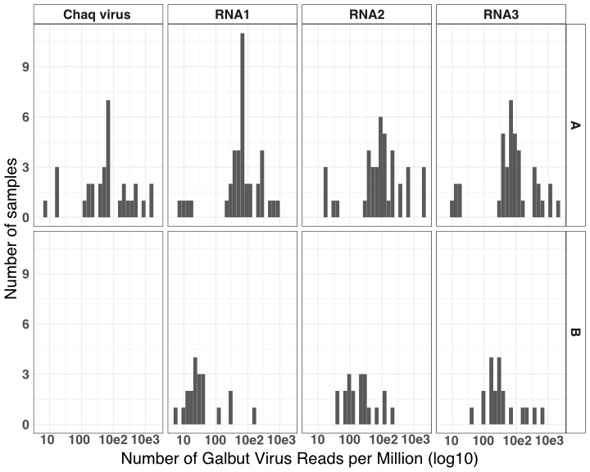

Supplemental Figure 7: Galbut virus does not show evidence of a bimodal or trimodal infection pattern.

**Galbut virus reassortment is more common between genotypes than across genotypes**

Reassortment – the shuffling of genome segments following co-infection is typical for viruses with segmented genomes [REF PMID [30212586](https://pubmed.ncbi.nlm.nih.gov/30212586/)]. There was evidence of reassortment among galbut virus segments. As one of many examples, sample 500-M-61-2, from Colorado in 2023, is classified as genotype A in all segments but RNAs 1 and 2 are on an isolated branch within A while RNA 3 is in clade A.1 (**Fig. 9, 10 & 11**). Another sample collected in the same location (2023 500-M-60) has two RNA 3 segments, one of each genotype while the RNA 1 and 2 segments indicate no partial segments and fall within genotype B (**Fig. 9, 10 & 11**). Within genotypes there is evidence of more diversity. For example, galbut virus RNA 2 of a 2023 Colorado sample (500-F-67) is clustered with Pennsylvania samples but in RNA 3 it is more similar to several samples from Maine and Colorado (**Fig. 9, 10 & 11**).

Two challenges: 1) short branch lengths, particularly within the galbut A clade 2) co-infection.

It was extremely rare for a galbut virus genotype B to also have chaq virus. There were five exceptions to this shown in our tanglegrams. Two were samples with complete galbut virus coinfections of genotypes A and B (ME-M-7 & Penn-F-4); it is likely that the chaq virus associated with these samples is part of the clade A sequences (**Fig. 12, 13 & 14**). The third exception to this is a Pennsylvania sample (Penn-F-6) with two RNA 2 sequences one of each genotype but no RNA 1 or 3 coding complete sequences (**Fig. 13**). The only exception that appears to be a true chaq virus infection of a galbut virus B genotype is a sample from Maine that had two chaq virus sequences but galbut virus sequences that fall within genotype B. The chaq virus sequences associated with this sample are part of different chaq virus clades (**Fig. 12, 13 & 14**).



**Figure 9: Co-phylogeny of galbut virus RNA1 and RNA 2.** Branches with support values < 0.001 were converted to polytomies prior to generation of the phylogeny. Trees were midpoint rooted. Sample names and lines are colored by coinfection status.



**Figure 10:** **Co-phylogeny of galbut virus RNA1 and RNA 3.** Branches with support values < 0.001 were converted to polytomies prior to generation of the phylogeny. Trees were midpoint rooted. Sample names and lines are colored by coinfection status.



**Figure 11:** **Co-phylogeny of galbut virus RNA 2 and RNA 3.** Branches with support values < 0.001 were converted to polytomies prior to generation of the phylogeny. Trees were midpoint rooted. Sample names and lines are colored by coinfection status.



**Figure 12:** **Co-phylogeny of galbut virus RNA1 and chaq virus.** Branches with support values < 0.001 were converted to polytomies prior to generation of the phylogeny. Trees were midpoint rooted. Sample names and lines are colored by coinfection status.



**Figure 13:** **Co-phylogeny of galbut virus RNA 2 and chaq virus.** Branches with support values < 0.001 were converted to polytomies prior to generation of the phylogeny. Trees were midpoint rooted. Sample names and lines are colored by coinfection status.



**Figure 14:** **Co-phylogeny of galbut virus RNA 3 and chaq virus.** Branches with support values < 0.001 were converted to polytomies prior to generation of the phylogeny. Trees were midpoint rooted. Sample names and lines are colored by coinfection status.

**DISCUSSION**

In this manuscript we describe the genetic diversity and evolutionary patterns of galbut virus, a persistent and ubiquitous viral infection of *D. melanogaster*3. Flies from Colorado, Pennsylvania, Maine, Ohio and an unknown location were screened for galbut virus. The RT-qPCR data showed that genotypes A and B cocirculate within populations, genotype B was less common than genotype A and flies could be infected at low or high levels (**Fig. 1**). One-hundred and fifty-five samples were selected for shotgun metagenomics. Most of the samples yielded coding complete or near complete galbut virus sequences that in combination with other available sequences were used to investigate galbut virus diversity and evolution.

We found that overall galbut virus sequence diversity is low. One way to explain this is by looking at the factors that allow a virus to maintain itself in a population. Highly studied persistent viral infections are generally acute infections that become persistent15–17. In the case of galbut virus, these viruses are transmitted vertically and are infections that occur over the lifetime of the host18,19. This close association between virus and host means that the pressures on galbut virus are different than persistent infections that only last the life of the host. The prisoner of war hypothesis is one way to understand this interaction20. Constraints have been placed on how much galbut virus can evolve due to its close relationship with the host. If the virus mutates in a way that harms *D. melanogaster’s* ability to pass the virus to its offspring, then it will be detrimental to the virus. Similarly, if the virus becomes pathogenic, then the fly’s fitness will decrease, and the virus will not be transmitted to the next generation.

We explored the potential of using time resolved phylogenetic methods to predict how long galbut virus has been infecting flies, when galbut virus jumped between hosts and to estimate the evolutionary rate. Even with 100+ sequences from diverse locations and sequences over 110-years-old, there was not enough diverity to identify a time signal when we tested with TempEst21. Galbut virus is simply not evolving fast enough to use tools like BEAST to estimate a time to most recent common ancestor22.

The overall structure of our trees were similar to a previous study12. Three clades of galbut virus were detected: clade A and B and a *D. simulans* clade. Our trees revealed that clade A of RNA 3 has two sub-clades: clade A.1 and A.2. The *D. simulans* clade was more closely related to clade B for RNA 1 and clade A for RNA 2 and 3 (**Fig. 4-7**). This suggests that *D. simulans* galbut virus is a reassortant of genotypes A and B23. How a host jump with a vertically transmitted virus would occur is unclear. Perhaps there is more successful inbreeding in the wild than thought24. There is partial evidence of geographic structure in our trees. All clade A sequences from Pennsylvania were highly similar while Maine sequences were dispersed throughout the tree. Sequences from diverse locations except for Australia were found within Colorado sequences (**Fig. 4-7**). The distinction between United States of America samples and Australia samples is likely due to the massive geographic distance between the two countries25.

The availability of sequences over time is limited. Sequences that were identified recently from specimens stored in museums showed surprising similarity to contemporary sequences12. The addition of more sequences confirms that even within highly sampled populations, diversity is low. These data are supported by the limited evidence of diversifying selection in galbut virus and chaq virus (**Table 2**). Galbut virus RNA 3 was the only segment to show evidence of selection which likely has to do with its unknown role. Perhaps RNA 3 is involved in the RNA interference response and host immune modualtion26,27.

We found that chaq virus was only associated with galbut clade A infections. There were no instances of clade B-only infection associated with the prescence of chaq virus. The only examples of clade B infections with chaq virus segments also contained a co-infecting clade A virus (e.g. ME-F-1, Penn-F-4, and ME-M-7). There are low- and high- infection levels associated with galbut virus infection but how it is implicated in clade A or B infection and whether chaq virus presence factors in was unknown. When we normalized the number of reads per segment by the total number of reads the high and low pattern was true for clade A infections but not for clade B infections (**Fig. 8**). Chaq virus infection was found in low- and high-level infections (**Fig. 8**). Therefore, it appears that chaq virus does not impact levels of galbut virus infection.

We found evidence of galbut virus coinfection in X% of flies. Most of these cases did not correspond to simple co-infection by 2 viruses (2 sets of 3 segments). Instead, …The biology of galbut virus coinfection is complex. Galbut virus coinfection does not require all segments. Forty-one samples had evidence of coinfection. Seventeen had a coding complete second sequence of at least one galbut virus segment or chaq virus segment (**Fig. 3**). Only two samples had complete coinfections. In both cases, these represented coinfections from each clade. Galbut virus RNA 3 represented the most coinfections while RNA 1 represented the fewest (**Fig. 3**). It is possible the role RNA 3 plays makes it more permissive to coinfection than RNA 1 or that RNA 1 is not specific to the transcripts it copies. Coinfection of one segment from each clade was also present. Samples 500-M-60 and Penn-M-2 had coding complete sequences from each clade in RNA 3 (**Fig. 3 & 6**).

We identified evidence that galbut virus reassorts. In all cases of potential reassortment between genotypes, there was coinfection of both clades (**Fig. 9-14**). Infections like this do suggest that replication of segments does not require all sequences to be from the same genotype. There is evidence of within genotype reassortment. RNA 1 and 2 of sample 500-M-61-2 and MEL191G from Australia, are on divergent branches within clade A but the RNA 3 sequences are similar to other RNA 3 sequences. When we investigated recombination, all recombination events identified by the RDP were explained as unaccounted-for low-level coinfection or the result of fluctuation in similarity by chance28.

To understand galbut virus infection in other *drosophila* species, particularly *D. simulans*, we used a nextflow based Sequence Read Archive mining strategy, but we were only able to recover galbut virus RNA 2 and 3 sequences for the RNA 1 and chaq virus sequences already available2. An effort to capture and sequence *D. simulans* from diverse regions would expand our knowledge of galbut virus evolution within this species and across species.

The study of how persistent viral infections evolve will continue to grow. As more sequences are deposited, the complex interactions that lead to lifelong infection of seemingly non-pathogenic viruses will be elucidated. This study has answered questions about the evolutionary trajectory of a common persistent viral infection of *D. melanogaster*. Studies like these will benefit from subsequential wet lab experiments to further investigate the biology of persistent virus evolution. There is strong evidence that these infections do not evolve in a way that is expected. More studies investigating these types of infections will be needed to further support these findings.

**MATERIALS AND METHODS**

*Sample Collection:* Approximately 1000 flies were collected over the summer of 2023 from Maine, Pennsylvania, Ohio, and Colorado, USA. Flies collected in Colorado were trapped in buckets baited with banana and yeast with organdy mesh (Oriole Textile, 2060) on top of the decaying fruit. Flies captured in Maine, Pennsylvania and Ohio were trapped using 3D printed fly traps8. A subset of flies collected in Colorado were isolated from California-grown peaches bought at a grocery store in Fort Collins, CO. It is unclear whether the flies arrived with the peaches or were local. We assigned these flies as being from Colorado, corresponding to where they were collected.

*RNA Extraction:* RNA was extracted from individual flies using a magnetic bead-based RNA/DNA capture method modified for use on the KingFisher (ThermoFisher Scientific). Briefly, flies were placed in an assay block (ThermoFisher Scientific, 9761116) with a small BB (McMaster Carr, 1598K22) and 100µL lysis buffer (20mM DTT (added fresh), 5M guanidine thiocyanate, 0.1M Tris-HCl (pH 7.5), 0.01M Na2EDTA (pH8)). Flies were homogenized at 30 Hz for three minutes in a TissueLyszer II (Qiagen). The homogenate was moved to a new deep well plate (Thermofisher, 9504050) and combined with a mastermix that included: 90µL homemade DNA/RNA magnetic beads (1.0 mL SpeedBeads (Cytiva, 65152105050250) in 1.0 mL TE (10mM Tris-HCl, 1mM EDTA) mixed in a 50 mL conical with 9.0g PEG-8000, 10 mL 5M NaCl, 500 μL 1M Tris-HCl, 100 μL 0.5M EDTA and 27.5 μL Tween 20 brought to 50 mL with sterile dH2O), 10µL lysis binding enhancer (Proteinase K 200 μg/mL, 20% glycerol, 0.5% SDS) and 60µL 100% isopropanol. In separate 96 well standard plates (ThermoFisher, 97002540), 150µL of wash buffer one (20% Ethanol, 900 mM guanidine thiocyanate, 10 mM Tris-HCl (pH 7.5)), wash buffer two (200mM TE, 80% Ethanol) and 50µL of sterile water was added. The extraction was completed on a KingFisher liquid handling robot (Thermo Scientific). Eluted nucleic acids were then stored at -80°C until further processing.

*Galbut virus positivity:* To determine which samples were positive for galbut virus, cDNA was generated using 5.5µL RNA, 0.75µM random hexamer primers (IDT), 0.75µM dNTPs and water to 13µL and incubated at 65°C for 5 minutes. Next, 4µL 5X FS buffer, 10M DTT and 1µL reverse transcriptase was added and incubated at 50°C for 60 minutes followed by a heat inactivation step at 80°C for 10 minutes after which each sample was diluted in 90µL nuclease-free water. qPCR was conducted using NEB Luna Universal qPCR Mastermix following manufacturer recommendations and cycling conditions (NEB, M3003). Each sample was screened for galbut virus using two primer sets (**Table 3**).

|  |  |  |  |  |
| --- | --- | --- | --- | --- |
| Primer pair name (#s in lab collection) | Galbut virus clade detection | Forward | Reverse | Reference |
| Galbut virus 1 (#1600/1601) | A | CCGTGAAGCAAGGAATCAAT | TGCCGATTTTCTGCTCTTTT | Cross 20201 |
| Galbut virus 2  (#2165/2170) | A and B | GTTCTTATCCGCATCGCCTA | AATTCACTACTTCCTTGACACCTC | This study |
| RpL32 mRNA (1012/1013) | NA | TGCTAAGCTGTCGCACAAATGG | TGCGCTTGTTCGATCCGTAAC | Cao 201629 |

*NGS Library Preparation:* Of the 641 galbut virus positive samples, 155 were selected for total RNA sequencing to recover galbut virus sequences. Samples were selected to represent diverse locations, galbut virus RNA levels (ranging from low to high), and qPCR melting temperature (ranging from identical to the positive control to 1˚C away). Sample concentration was obtained using the Qubit high-sensitivity RNA reagent (ThermoFisher, Q32852) and DNA was removed via a DNAse I treatment (NEB B0303S). Prior to library preparation, samples were normalized to 5 ng/µL except where sample concentrations were too low. In these cases, either a different sample was selected, or the maximum volume of input RNA was used. Samples were split into two batches of ≤ 96 samples and prepared for sequencing using the Kapa RNA Hyper Prep kit following manufacturer recommendations (Roche, 08098093702). Eight cycles of library amplification were performed. Adapters contained unique dual indices (Integrated DNA Technologies xGen UDI/UMI 10005903). HeLa cell total RNA was used as a positive control and water was used as a negative control for both library preparations and sequencing. Sample pooling was determined using High Sensitivity DNA Qubit reagents and final library quality control was done using an Agilent D1000 HS Tapestation and KapaQuant reagents following manufacturers recommendations (Roche, 07960140001). Both pools were sent to Azenta/Genewiz where they were sequenced on a NovaSeq 6000 with 2X150 paired end sequencing.

**Data Analysis**

*Identification of galbut virus sequences:* We used our lab’s previously described virus taxonomy pipeline ([https://github.com/stenglein-lab/taxonomy\_pipeline](https://github.com/stenglein-lab/taxonomy_pipeline" \t "_blank)) to identify and validate galbut virus sequences in the NGS datasets12. In brief, adapters and low-quality reads were trimmed using cutadapt 3.530. Fastqc 0.11.931 was used to assess post-collapsed read quality. Host reads were removed using bowtie2 2.4.532 and the remaining reads were assembled using spades 3.15.433. Virus sequences were identified using BLASTn 2.12.0. Draft sequences were validated by remapping of trimmed reads using bwa mem aligner version 0.7.1734. Final sequences were submitted to the NCBI nucleotide database and raw NGS data to the NCBI sequence read archive repository (see Data Availability statement below).

*Molecular species identification:* To confirm the species identification of the samples, we used our labs species identification pipeline (<https://github.com/stenglein-lab/species_id>)12. In brief, this pipeline takes preprocessed reads and competitively maps them to a set of 529 cytochrome c oxidase subunit 1 sequences from across the Drosophilidae family. This pipeline identified one *Drosophila affinis*, one *Drosophila simulans* and 147 *D. melanogaster*. Six samples remained unidentified as they did not confidently align to any of the available cytochrome c oxidase subunit 1 sequences from GenBank.

*Maximum Likelihood trees:* All available galbut virus and chaq virus sequences with a known location, date of collection and were from individual flies were downloaded from GenBank. Alignments were generated using MAFFTT v7.490 with default parameters35. IQ-TREE v2.3.6 was used to generate maximum likelihood trees36. IQ-TREE parameters were: **singularity exec iqtree:2.3.6--h503566f\_1 iqtree2 -s $fasta --threads-max $num\_threads -T AUTO --mem 33% -B 1000 -alrt 1000**. iTol was used for tree visualization37. Trees were midpoint rooted. Bootstrap support values at large branches were retained.

*Selection analysis:* We used the Fixed Effects Likelihood model described by Kosakovsk-Pond and Frost14. This analysis was run on Datamonkey with the HyPhy application38,39. We explored the FUBAR method (fast, unconstrained Bayesian approximation) and had similar results for galbut virus RNAs 1 and 2 and chaq virus however considerably less sites of positive selection were identified in RNA 340. Given that the RNA 3 alignment had sequence similarities between -76% and 100%, the results from the FEL method were more appropriate.

*Recombinant detection analysis:* We performed recombination detection analysis using the Recombination Detection Program28,41 which identified one candidate recombination event in chaq virus and another in galbut virus RNA 3. We used a custom script using Bio-python and R to count and then visualize the percent identity between the candidate recombination events. This visualization led us to conclude that the chaq virus recombinant was the result of a chimera of two partial chaq virus sequences. We were unable to recover a coding complete sequence of these sequences. Inspection of pairwise alignments of the potential RNA 3 recombination event was not convincing. The similarity between the recombination regions could be explained by natural variations in similarity.

*Cophylogeny analysis*: Tanglegrams were generated in R/RStudio using the phytools and ape packages42,43. Branches shorter than 0.001 were turned into polytomies to avoid false positive signals of reassortment from short branches.

**ACKNOWLEDGEMENTS**

The authors would like to acknowledge the individuals that volunteered to collect wild flies: Lisa Harrington and Paul Keene, Khwannarin Khemsom, Anastazia Jablumovsky, Elle Irons and Michael Martzahn, Kelly Wallace and Ben Ryan, Claire Stewart and Natali Wickencamp and the packaging department at New Belgium Brewing Company. We thank them for their effort in collecting flies themselves or for the opportunity for us to collect flies from their property. Did any other lab members contribute to collection, testing, etc?

**DATA AVAILABILITY**

The sequencing data that supports the findings of this study are openly available in the National Center for Biotechnology and Information under the SRA accession numbers: SRR30712177-SRR30712331 and the nucleotide accession numbers: PQ624841-PQ625194, PQ625196-PQ625214, and [ADD SRA accessions]. The scripts used to analyze the data, raw RT-qPCR data and metadata can be found at this GitHub repository: <https://github.com/LKeene/DiverseCollections>.

**FUNDING**

NSF IOS 2048214 (AHK, ALB and MDS), NIH T32GM132057 (AHK), and NIH/NCATS Colorado CTSA Grant Number UL1 TR002535

**REFERENCES**

1. Cross, S. T. *et al.* Partitiviruses Infecting Drosophila melanogaster and Aedes aegypti Exhibit Efficient Biparental Vertical Transmission. *J Virol* **94**, (2020).

2. Ortiz-Baez, A. S., Shi, M., Hoffmann, A. A. & Holmes, E. C. RNA virome diversity and Wolbachia infection in individual Drosophila simulans flies. *J Gen Virol* **102**, 001639 (2021).

3. Webster, C. L. *et al.* The Discovery, Distribution, and Evolution of Viruses Associated with Drosophila melanogaster. *PLoS Biol* **13**, e1002210 (2015).

4. Wallace, M. A. & Obbard, D. J. Naturally occurring viruses of *Drosophila* reduce offspring number and lifespan. *Proceedings of the Royal Society B: Biological Sciences* **291**, (2024).

5. Cross, S. T. *et al.* Galbut Virus Infection Minimally Influences Drosophila melanogaster Fitness Traits in a Strain and Sex-Dependent Manner. *Viruses* **15**, 539 (2023).

6. Keller, A. Drosophila melanogaster’s history as a human commensal. *Current Biology* **17**, PR77-R81 (2007).

7. Wallace, M. A. *et al.* The discovery, distribution, and diversity of DNA viruses associated with *Drosophila melanogaster* in Europe. *Virus Evol* **7**, veab031 (2021).

8. Keene-Snickers, A. H., Dunham, T. J. & Stenglein, M. D. Experimental assessment of 3D-printed traps and chemical attractants for the collection of wild Drosophila melanogaster. Preprint at https://doi.org/10.1101/2025.01.28.635319 (2025).

9. Albrecht, T. *et al.* Occurrence of Wheat Curl Mite and Mite-Vectored Viruses of Wheat in Colorado and Insights into the Wheat Virome. *Plant Dis* **106**, 2678–2688 (2022).

10. Kapuscinski, M. L. *et al.* Genomic characterization of 99 viruses from the bunyavirus families Nairoviridae, Peribunyaviridae, and Phenuiviridae, including 35 previously unsequenced viruses. *PLoS Pathog* **17**, e1009315 (2021).

11. Stenglein, M. D. *et al.* Widespread recombination, reassortment, and transmission of unbalanced compound viral genotypes in natural arenavirus infections. *PLoS Pathog* **11**, e1004900 (2015).

12. Keene, A. H. & Stenglein, M. D. Sequencing RNA from old, dried specimens reveals past viromes and properties of long-surviving RNA. Preprint at https://doi.org/10.1101/2024.10.03.616531 (2024).

13. Botella, L., Vainio, E. J., Hantula, J., Diez, J. J. & Jankovsky, L. Description and prevalence of a putative novel mycovirus within the conifer pathogen Gremmeniella abietina. *Arch Virol* **160**, 1967–1975 (2015).

14. Kosakovsky Pond, S. L. & Frost, S. D. W. Not So Different After All: A Comparison of Methods for Detecting Amino Acid Sites Under Selection. *Mol Biol Evol* **22**, 1208–1222 (2005).

15. Boldogh, I., Albrecht, T. & Porter, D. D. *Persistent Viral Infections*. (Galveston, TX, 1996).

16. Sullivan, B. M., Teijaro, J. R., de la Torre, J. C. & Oldstone, M. B. A. Early Virus-Host Interactions Dictate the Course of a Persistent Infection. *PLoS Pathog* **11**, 1–14 (2015).

17. Hilleman, M. R. Strategies and mechanisms for host and pathogen survival in acute and persistent viral infections. *Proceedings of the National Academy of Sciences* **101**, 14560–14566 (2004).

18. Nibert, M. L. *et al.* Taxonomic reorganization of family Partitiviridae and other recent progress in partitivirus research. *Virus Res* **188**, 128–41 (2014).

19. Ghabrial, S. A., Ochoa, W. F., Baker, T. S. & Nibert, M. L. Partitiviruses: General Features. in *Encyclopedia of Virology (Third Edition)* (eds. Mahy, B. W. J. & Van Regenmortel, M. H. V) 68–75 (Academic Press, Oxford, 2008). doi:https://doi.org/10.1016/B978-012374410-4.00573-2.

20. Simmonds, P., Aiewsakun, P. & Katzourakis, A. Prisoners of war — host adaptation and its constraints on virus evolution. *Nat Rev Microbiol* **17**, 321–328 (2019).

21. Rambaut, A., Lam, T. T., Max Carvalho, L. & Pybus, O. G. Exploring the temporal structure of heterochronous sequences using TempEst (formerly Path-O-Gen). *Virus Evol* **2**, vew007 (2016).

22. Suchard, M. A. *et al.* Bayesian phylogenetic and phylodynamic data integration using BEAST 1.10. *Virus Evol* **4**, (2018).

23. ALEXANDER, D. J. & BROWN, I. H. Recent zoonoses caused by influenza A viruses. *Revue Scientifique et Technique de l’OIE* **19**, 197–225 (2000).

24. CASTLE, W. E. INBREEDING, CROSS-BREEDING AND STERILITY IN DROSOPHILA. *Science (1979)* **23**, 153–153 (1906).

25. Kolodziejek, J. *et al.* Genetic clustering of Borna disease virus natural animal isolates, laboratory and vaccine strains strongly reflects their regional geographical origin. *Journal of General Virology* **86**, 385–398 (2005).

26. Swevers, L., Broeck, J. Vanden & Smagghe, G. The possible impact of persistent virus infection on the function of the RNAi machinery in insects: A hypothesis. *Front Physiol* **4 NOV**, (2013).

27. Karlikow, M., Goic, B. & Saleh, M. C. RNAi and antiviral defense in Drosophila: Setting up a systemic immune response. *Dev Comp Immunol* **42**, 85–92 (2014).

28. Martin, D. & Rybicki, E. RDP: detection of recombination amongst aligned sequences. *Bioinformatics* **16**, 562–563 (2000).

29. Cao, C., Magwire, M. M., Bayer, F. & Jiggins, F. M. A Polymorphism in the Processing Body Component Ge-1 Controls Resistance to a Naturally Occurring Rhabdovirus in Drosophila. *PLoS Pathog* **12**, e1005387 (2016).

30. Martin, M. Cutadapt Removes Adapter Sequences From High-Throughput Sequencing Reads. *EMBnet J* **17**, 10–12 (2011).

31. Andrews, S. *et al.* FastQC: a quality control tool for high throughput sequence data. https://qubeshub.org/resources/fastqc (2012).

32. Langmead, B. & Salzberg, S. L. Fast gapped-read alignment with Bowtie 2. *Nat Methods* **9**, 357–359 (2012).

33. Prjibelski, A., Antipov, D., Meleshko, D., Lapidus, A. & Korobeynikov, A. Using SPAdes De Novo Assembler. *Curr Protoc Bioinformatics* **70**, e102 (2020).

34. Li, H. & Durbin, R. Fast and accurate long-read alignment with Burrows-Wheeler transform. *Bioinformatics* **26**, 589–595 (2010).

35. Katoh, K. & Standley, D. M. MAFFT multiple sequence alignment software version 7: Improvements in performance and usability. *Mol Biol Evol* **30**, 772–780 (2013).

36. Nguyen, L. T., Schmidt, H. A., Von Haeseler, A. & Minh, B. Q. IQ-TREE: A fast and effective stochastic algorithm for estimating maximum-likelihood phylogenies. *Mol Biol Evol* **32**, 268–274 (2015).

37. Letunic, I. & Bork, P. Interactive Tree of Life (iTOL) v6: recent updates to the phylogenetic tree display and annotation tool. *Nucleic Acids Res* **52**, W78–W82 (2024).

38. Weaver, S. *et al.* Datamonkey 2.0: A Modern Web Application for Characterizing Selective and Other Evolutionary Processes. *Mol Biol Evol* **35**, 773–777 (2018).

39. Kosakovsky Pond, S. L. *et al.* HyPhy 2.5—A Customizable Platform for Evolutionary Hypothesis Testing Using Phylogenies. *Mol Biol Evol* **37**, 295–299 (2020).

40. Murrell, B. *et al.* FUBAR: A Fast, Unconstrained Bayesian AppRoximation for Inferring Selection. *Mol Biol Evol* **30**, 1196–1205 (2013).

41. Martin, D. P. *et al.* RDP5: a computer program for analyzing recombination in, and removing signals of recombination from, nucleotide sequence datasets. *Virus Evol* **7**, (2021).

42. Revell, L. J. phytools: Phylogenetic Tools for Comparative Biology (and Other Things). *CRAN: Contributed Packages* Preprint at https://doi.org/10.32614/CRAN.package.phytools (2011).

43. Paradis, E. *et al.* ape: Analyses of Phylogenetics and Evolution. *CRAN: Contributed Packages* Preprint at https://doi.org/10.32614/CRAN.package.ape (2002).